-- EXERCISE 8

-- 1. How many unique salary packages does our company “Bignet” offer? List them in descending order.
SELECT DISTINCT SALARY
FROM EMPLOYEE_DATA
ORDER BY SALARY DESC;
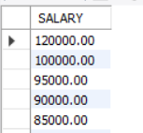
SELECT COUNT(DISTINCT SALARY) AS UNIQUE_SALARY_PACKAGES FROM EMPLOYEE_DATA;
-- unique_salary_packages:18
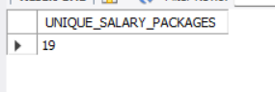
-- 2. How many distinct first names do we have in our database?
SELECT COUNT(DISTINCT F_NAME) AS DISTINCT_FIRST_NAMES
FROM EMPLOYEE_DATA;
SELECT DISTINCT F_NAME
FROM EMPLOYEE_DATA
ORDER BY F_NAME ASC;
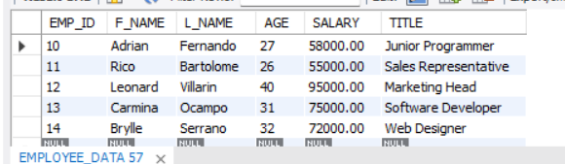

CREATE DATABASE IF NOT EXISTS EXERCISE8_DB;
USE EXERCISE8_DB;
CREATE TABLE EMPLOYEE_DATA (
EMP_ID INT AUTO_INCREMENT PRIMARY KEY,
F_NAME VARCHAR(50),
L_NAME VARCHAR(50),
AGE INT,
SALARY DECIMAL(10,2),
TITLE VARCHAR(100)
);
INSERT INTO EMPLOYEE_DATA (F_NAME, L_NAME, AGE, SALARY, PERKS, TITLE) VALUES
('Kishey', 'Gacute', 34, 80000, 5000, 'Programmer'),
('Kim', 'Ricaro', 33, 90000, 7000, 'Marketing Executive'),
('Trisha', 'Ogbac', 35, 85000, 4000, 'Sales Associate'),
('Recelle', 'Janda', 45, 100000, 10000, 'Senior Programmer'),
('Alessandra', 'Rivano', 29, 75000, 3000, 'Web Designer'),
('Jamaima', 'Rabulan', 25, 65000, 2500, 'Finance Assistant'),
('Fate', 'Caraan', 36, 120000, 9000, 'Marketing Manager'),
('Mariel', 'Cuenca', 28, 70000, 3500, 'HR Assistant'),
('Melody', 'Monreal', 30, 65000, 2000, 'Marketing Staff'),
('Mark', 'Pedernal', 27, 58000, 1500, 'Junior Programmer'),
('Kim', 'Villareal', 26, 55000, 1000, 'Sales Representative'),
('Manuel', 'Santiago', 40, 95000, 8500, 'Marketing Head'),
('Alona', 'Navarro', 31, 75000, 4000, 'Software Developer'),
('Patrick', 'Dionisio', 32, 72000, 4200, 'Web Designer'),
('Faye', 'Dimaculangan', 30, 77000, 3900, 'Programmer'),
('Ramon', 'Lazaro', 24, 50000, 1200, 'Intern'),
('Julia', 'Bautista', 22, 48000, 900, 'Trainee'),
('EJ', 'Valdez', 23, 49000, 1000, 'Office Assistant'),
('Marie', 'Abad', 21, 46000, 800, 'Receptionist'),
('Janelle', 'Aquino', 20, 45000, 500, 'Clerk'),
('Lance', 'Garcia', 25, 52000, 1100, 'Junior Web Designer');

